**PROJECT REPORT**

**Predicting Employee Attrition**

*Submitted towards the partial fulfillment of the criteria for award of PGDA by Imarticus*

*Submitted By:*

*Aneesh B Avati*

*Course and Batch: PGDA June 2018*



# Abstract

Title: Predicting Employee Attrition

To investigate how the company objective factors, influence in attrition of employees, and what kind of working environment is most likely to cause attrition.

# Acknowledgements

**[To be changed by candidates as per their requirement]**

We are using this opportunity to express my gratitude to everyone who supported us throughout the course of this group project. We are thankful for their aspiring guidance, invaluably constructive criticism and friendly advice during the project work. I am sincerely grateful to them for sharing their truthful and illuminating views on a number of issues related to the project.

Further, I am fortunate to have Tharangini Vijaykumar as our mentor. She has readily shared his immense knowledge in data analytics and guide us in a manner that the outcome resulted in enhancing our data skills.

We wish to thank, all the faculties, as this project utilized knowledge gained from every course that formed the PGA program.

We certify that the work done by us for conceptualizing and completing this project is original and authentic.

Date: Dec 13, 2018 Aneesh B Avati

Place: Bengaluru

# Certificate of Completion

**[To be changed by candidates as per their requirement]**

I hereby certify that the project titled “Predicting Employee Attrition” was undertaken and completed under my supervision by Member 1 and Member 1 from the batch of PGDA (June 2018)

Mentor: Tharangini Vijaykumar

Date: December 13, 2018

Place – Bangalore

Table of Contents

Abstract 2

Acknowledgements 2

Certificate of Completion 3

CHAPTER 1: INTRODUCTION 6

1.1 Title & Objective of the study 6

1.2 Need of the Study 6

1.3 Business or Enterprise under study: 6

1.4 Business Model of Enterprise: 6

1.5 Data Sources : 6

1.6 Tools & Techniques 6

1.7 Infrastructure Challenges 7

CHAPTER 2: DATA PREPARATION AND UNDERSTANDING 8

2.1 Phase I – Data Extraction and Cleaning: 8

2.2 Phase II - Data Visualization: 12

2.2 Phase III - Feature Engineering 40

2.3 Exploratory Data Analysis: 43

CHAPTER 3: FITTING MODELS TO DATA 46

3.1 LOGISTIC REGRESSION MODEL 46

3.1.1 First Logistic Regression Model 46

3.1.2 Model Validation 48

3.1.3 Second Logistic Regression model 49

3.1.4 Comparison of Linear Regression model 50

3.2 DECESION TREE 51

3.2.1 Decision Tree model 51

3.2.2 Decision Tree Prediction 52

3.2.3 Decision Tree Confusion Matrix 52

3.2.4 Plotting AUC Curce 53

3.3 RANDOM FOREST 53

3.3.1 Random Forest model 53

3.3.2 Random Forest Model Prediction 54

3.3.3 Random Forest model Confusion Matrix 54

3.3.4 Random Forest model AUC Curve: 54

3.4 SVM 55

3.4.1 SVM tuning 55

3.4.2 SVM model Building with Different Kernals 56

3.4.3 SVM models Prediction 59

3.4.4 SVM Models Confusion Matrix 59

3.4.5 SVM Model Accuracy 59

3.4.6 Plotting AUC Curve: 60

3.5 EXTREME GRADIENT BOOSTING 61

3.5.1 XGB model 61

3.5.2 XGB model Prediction and Confusion Matrix 62

3.5.3 XGB model AUC Curve 62

CHAPTER 5: KEY FINDINGS 64

CHAPTER 6: RECOMMENDATIONS AND CONCLUSION 66

CHAPTER 7: REFERENCES 67

# CHAPTER 1: INTRODUCTION

## Title & Objective of the study

***Title***: Predicting Employee Attrition

***Objective***: To investigate how the company objective factors influence in attrition of employees, and what kind of working environment is most likely to cause attrition.

## Need of the Study

How does Attrition affect companies? and how does HR Analytics help in analyzing attrition? A major problem in high employee attrition is its cost to an organization. Job postings, hiring processes, paperwork and new hire training are some of the common expenses of losing employees and replacing them.

## Business or Enterprise under study:

IBM

## Business Model of Enterprise:

Uncover the factors that lead to employee attrition and explore important questions such as ‘show me a breakdown of distance from home by job role and attrition’ or ‘compare average monthly income by education and attrition’. This is a fictional data set created by IBM data scientists.

## 1.5 Data Sources :

I am using a dataset put up by IBM for my analysis. The dataset contains 35 variables along with Attrition variable. It can be downloaded from:

<https://www.kaggle.com/pavansubhasht/ibm-hr-analytics-attrition-dataset>

## 1.6 Tools & Techniques

*Tools*:

1. R

*Libraries used:* Some basic libraries used for analysis & model building are mentioned below

* *library(Amelia)* - A Program for Missing Data. A tool that "multiply imputes" missing data
* *library(ROCR)* - ROCR is a flexible tool for creating cutoff-parameterized 2D performance curves ...
* *library(ggplot2)* - ggplot2 is a system for declaratively creating graphics, based on [The Grammar of Graphics](http://amzn.to/2ef1eWp). You provide the data, tell ggplot2 how to map variables to aesthetics, what graphical primitives to use, and it takes care of the details.
* *library(plyr)* - Tools for Splitting, Applying and Combining Data.
* *library(e1071)* - Functions for latent class analysis, short time Fourier transform, fuzzy clustering, support vector machines, shortest path computation, bagged clustering, naive Bayes classifier etc.
* *library(rpart)* - Recursive Partitioning and Regression Trees.
* *library(caret)* - is a set of functions that attempt to streamline the process for creating predictive models
* *library(dplyr)* - A Grammar of Data Manipulation. A fast, consistent tool for working with data frame
* *library(class)* - Various functions for classification, including k-nearest neighbor
* *library(lattice)* - attempts to improve on base **R** graphics by providing better defaults and the ability to easily display multivariate relationships.
* *library(caTools)* - for random data splitting.
* *library(neuralnet)* - Training of Neural Networks.
* *library(hydroGOF)* – for computing goodness-of-fit measures

1. R Markdown

* library(knitr) -  A General-Purpose Package for Dynamic Report Generation in R.

*Techniques*:

I shall be looking at all variables through some plots and infer about it in my exploratory analysis. And through my exploration I shall try to identify the Variables that tend to have an impact in the attrition of the most experienced and talented employees and try to fit a classification models and use it to test hypotheses and draw inferences.

The problem will be explored in following stages:

1. **Hypothesis Generation** – understanding the problem statement better by working out possible factors that can have impact on the outcome
2. **Data Exploration (EDA)** – looking at categorical and continuous variables summaries and making inferences about the data.
3. **Data Cleaning** – imputing missing values in the data and checking for outliers and eliminating insignificant Variables form data set, scaling.
4. **Data Splitting** – Randomly splitting the data set into train (80%) and test (20%) data sets.
5. **Feature Engineering** – modifying existing variables and creating new ones for analysis.
6. **Model Building** – making predictive models on the train data and testing it.
7. **Champion Model Selection** – after building multiple predictive models, the model with high accuracy is selected as Champion model

## 1.7 Infrastructure Challenges

* The dataset given to us is imbalanced. The attrition percentage rate (Target Variable) is imbalanced. Hence the challenge faced is due to data imbalance.
* Lot of variables in the dataset are actually factors but when imported they are numeric in nature.

# CHAPTER 2: DATA PREPARATION AND UNDERSTANDING

One of the first steps we engaged in was to outline the sequence of steps that we will be following for our project. Each of these steps are elaborated below

## Phase I – Data Extraction and Cleaning:

* **Data Extraction:**

HRA1 <- read.csv("D:/imarticus/Project/Attrition.csv",na.strings=c(""," ","NA"))  
summary(HRA1)

## Age Attrition BusinessTravel DailyRate   
## Min. :18.00 No :1233 Non-Travel : 150 Min. : 102.0   
## 1st Qu.:30.00 Yes: 237 Travel_Frequently: 277 1st Qu.: 465.0   
## Median :36.00 Travel_Rarely :1043 Median : 802.0   
## Mean :36.92 Mean : 802.5   
## 3rd Qu.:43.00 3rd Qu.:1157.0   
## Max. :60.00 Max. :1499.0   
##   
## Department DistanceFromHome Education   
## Human Resources : 63 Min. : 1.000 Min. :1.000   
## Research & Development:961 1st Qu.: 2.000 1st Qu.:2.000   
## Sales :446 Median : 7.000 Median :3.000   
## Mean : 9.193 Mean :2.913   
## 3rd Qu.:14.000 3rd Qu.:4.000   
## Max. :29.000 Max. :5.000   
##   
## EducationField EmployeeCount EmployeeNumber   
## Human Resources : 27 Min. :1 Min. : 1.0   
## Life Sciences :606 1st Qu.:1 1st Qu.: 491.2   
## Marketing :159 Median :1 Median :1020.5   
## Medical :464 Mean :1 Mean :1024.9   
## Other : 82 3rd Qu.:1 3rd Qu.:1555.8   
## Technical Degree:132 Max. :1 Max. :2068.0   
##   
## EnvironmentSatisfaction Gender HourlyRate JobInvolvement  
## Min. :1.000 Female:588 Min. : 30.00 Min. :1.00   
## 1st Qu.:2.000 Male :882 1st Qu.: 48.00 1st Qu.:2.00   
## Median :3.000 Median : 66.00 Median :3.00   
## Mean :2.722 Mean : 65.89 Mean :2.73   
## 3rd Qu.:4.000 3rd Qu.: 83.75 3rd Qu.:3.00   
## Max. :4.000 Max. :100.00 Max. :4.00   
##   
## JobLevel JobRole JobSatisfaction  
## Min. :1.000 Sales Executive :326 Min. :1.000   
## 1st Qu.:1.000 Research Scientist :292 1st Qu.:2.000   
## Median :2.000 Laboratory Technician :259 Median :3.000   
## Mean :2.064 Manufacturing Director :145 Mean :2.729   
## 3rd Qu.:3.000 Healthcare Representative:131 3rd Qu.:4.000   
## Max. :5.000 Manager :102 Max. :4.000   
## (Other) :215   
## MaritalStatus MonthlyIncome MonthlyRate NumCompaniesWorked  
## Divorced:327 Min. : 1009 Min. : 2094 Min. :0.000   
## Married :673 1st Qu.: 2911 1st Qu.: 8047 1st Qu.:1.000   
## Single :470 Median : 4919 Median :14236 Median :2.000   
## Mean : 6503 Mean :14313 Mean :2.693   
## 3rd Qu.: 8379 3rd Qu.:20462 3rd Qu.:4.000   
## Max. :19999 Max. :26999 Max. :9.000   
##   
## Over18 OverTime PercentSalaryHike PerformanceRating  
## Y:1470 No :1054 Min. :11.00 Min. :3.000   
## Yes: 416 1st Qu.:12.00 1st Qu.:3.000   
## Median :14.00 Median :3.000   
## Mean :15.21 Mean :3.154   
## 3rd Qu.:18.00 3rd Qu.:3.000   
## Max. :25.00 Max. :4.000   
##   
## RelationshipSatisfaction StandardHours StockOptionLevel TotalWorkingYears  
## Min. :1.000 Min. :80 Min. :0.0000 Min. : 0.00   
## 1st Qu.:2.000 1st Qu.:80 1st Qu.:0.0000 1st Qu.: 6.00   
## Median :3.000 Median :80 Median :1.0000 Median :10.00   
## Mean :2.712 Mean :80 Mean :0.7939 Mean :11.28   
## 3rd Qu.:4.000 3rd Qu.:80 3rd Qu.:1.0000 3rd Qu.:15.00   
## Max. :4.000 Max. :80 Max. :3.0000 Max. :40.00   
##   
## TrainingTimesLastYear WorkLifeBalance YearsAtCompany YearsInCurrentRole  
## Min. :0.000 Min. :1.000 Min. : 0.000 Min. : 0.000   
## 1st Qu.:2.000 1st Qu.:2.000 1st Qu.: 3.000 1st Qu.: 2.000   
## Median :3.000 Median :3.000 Median : 5.000 Median : 3.000   
## Mean :2.799 Mean :2.761 Mean : 7.008 Mean : 4.229   
## 3rd Qu.:3.000 3rd Qu.:3.000 3rd Qu.: 9.000 3rd Qu.: 7.000   
## Max. :6.000 Max. :4.000 Max. :40.000 Max. :18.000   
##   
## YearsSinceLastPromotion YearsWithCurrManager  
## Min. : 0.000 Min. : 0.000   
## 1st Qu.: 0.000 1st Qu.: 2.000   
## Median : 1.000 Median : 3.000   
## Mean : 2.188 Mean : 4.123   
## 3rd Qu.: 3.000 3rd Qu.: 7.000   
## Max. :15.000 Max. :17.000   
##

names(HRA1)

## [1] "Age" "Attrition"   
## [3] "BusinessTravel" "DailyRate"   
## [5] "Department" "DistanceFromHome"   
## [7] "Education" "EducationField"   
## [9] "EmployeeCount" "EmployeeNumber"   
## [11] "EnvironmentSatisfaction" "Gender"   
## [13] "HourlyRate" "JobInvolvement"   
## [15] "JobLevel" "JobRole"   
## [17] "JobSatisfaction" "MaritalStatus"   
## [19] "MonthlyIncome" "MonthlyRate"   
## [21] "NumCompaniesWorked" "Over18"   
## [23] "OverTime" "PercentSalaryHike"   
## [25] "PerformanceRating" "RelationshipSatisfaction"  
## [27] "StandardHours" "StockOptionLevel"   
## [29] "TotalWorkingYears" "TrainingTimesLastYear"   
## [31] "WorkLifeBalance" "YearsAtCompany"   
## [33] "YearsInCurrentRole" "YearsSinceLastPromotion"   
## [35] "YearsWithCurrManager"

dim(HRA1)

## [1] 1470 35

As observed from the dataset, our target Variable with which we can point our model to train on would be the "Attrition" column. The dataset has a mix of numerical and categorical data types. This section will be devoted to data exploration and as a first step, let us quickly carry our some simple data completeness checks to see if there are nulls or infinite values in the data

* **Missing Value Analysis and Treatment**

colSums(is.na(HRA1))

## Age Attrition BusinessTravel   
## 0 0 0   
## DailyRate Department DistanceFromHome   
## 0 0 0   
## Education EducationField EmployeeCount   
## 0 0 0   
## EmployeeNumber EnvironmentSatisfaction Gender   
## 0 0 0   
## HourlyRate JobInvolvement JobLevel   
## 0 0 0   
## JobRole JobSatisfaction MaritalStatus   
## 0 0 0   
## MonthlyIncome MonthlyRate NumCompaniesWorked   
## 0 0 0   
## Over18 OverTime PercentSalaryHike   
## 0 0 0   
## PerformanceRating RelationshipSatisfaction StandardHours   
## 0 0 0   
## StockOptionLevel TotalWorkingYears TrainingTimesLastYear   
## 0 0 0   
## WorkLifeBalance YearsAtCompany YearsInCurrentRole   
## 0 0 0   
## YearsSinceLastPromotion YearsWithCurrManager   
## 0 0

There are no missing values in the dataset.

* **Handling Outliers**

boxplot(HRA1)

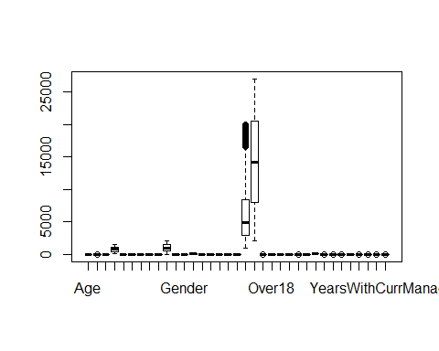

Here the outliers observed in above image are from the variables monthly income and Monthly rate. These two variables are qualitative in nature and can vary with respect to other independent variables. Hence there is no need to address this outliers.

* **Correlation Parameters**

The next tool in a data explorer's arsenal is that of a correlation matrix. By plotting a correlation matrix, we have a very nice overview of how the features are related to one another.

In this correlation plot, I will use the coorplot library to produce a interactive Pearson correlation matrix via this function as follows:

library(corrplot)  
corrplot(cor(sapply(HRA,as.integer)),method = "pie")

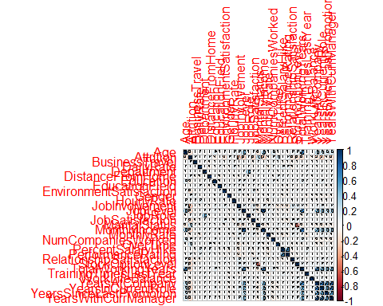

From the correlation plots, we can see that quite a lot of our columns seem to be poorly correlated with one another. Generally, when making a predictive model, it would be preferable to train a model with features that are not too correlated with one another so that we do not need to deal with redundant features. In the case that we have quite a lot of correlated features one could perhaps apply a technique such as Principal Component Analysis (PCA) to reduce the feature space.

## Phase II - Data Visualization:

* **Data visualization:**

library(magrittr)  
library(ggplot2)  
library(knitr)  
library(ggthemes)  
library(dplyr)

**Distribution of Age**

ggplot(HRA,aes(Age))+geom_histogram(binwidth=5,aes(y=..count..),fill="green4")+theme(legend.position="none",plot.title = element_text(hjust=0.5,size=15))+labs(x="Age",y="Count",title="Distribution of Age")

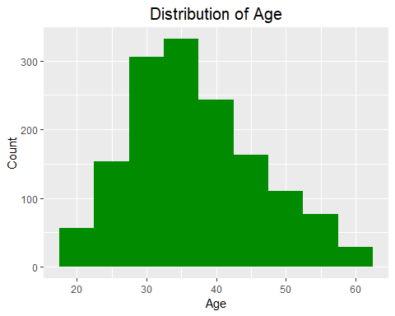

From the plot, we understand that median age is between 30 to 40 years and maximum is 60 years. Let us correlate this with the attrition levels.

**Age Distribution Of People Who Leave**

ggplot(HRA, aes(Age))+geom_histogram(binwidth=5,aes(y=round(((..count..)/sum(..count..))*100,2)),fill="red")+theme_few()+theme(legend.position="none",plot.title = element_text(hjust=0.5,size=15))+labs(x="Age",y="Percentage",title="Age distribution of people who leave")+scale_y_continuous(limits=c(0,30),breaks=seq(0,30,5))+scale_x_continuous(limits=c(15,60),breaks=seq(15,60,5))

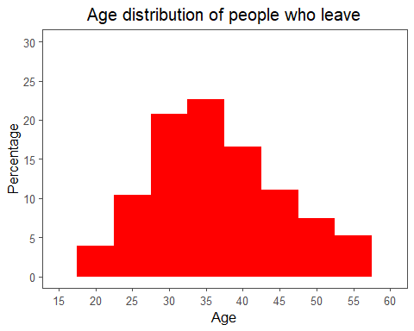

* Almost ,30 % of the people who leave are about 30 years and a significant percentage fall below 40 years of age.

**Age Distribution Of People Who Stay**

ggplot(HRA,aes(Age))+geom_histogram(binwidth=5,aes(y=round(((..count..)/sum(..count..))*100,2)),fill="green4")+theme_few()+theme(legend.position="none",plot.title = element_text(hjust=0.5,size=15))+labs(x="Age",y="Percentage",title="Age distribution of people who Stay")+scale_y_continuous(limits=c(0,30),breaks=seq(0,30,5))+scale_x_continuous(limits=c(15,60),breaks=seq(15,60,5))

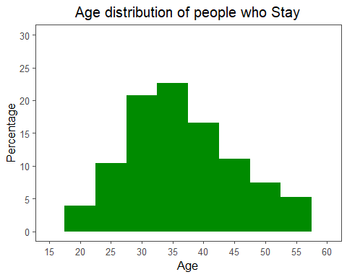

* A significant % of people who do not leave the company are of age 35 to 40 years as described by the plot.

Let us check the salary difference among males and females.

**Salary With Gender**

ggplot(HRA,aes(Gender,MonthlyIncome,fill=Gender))+geom_boxplot()+theme_few()+theme(legend.position="none",plot.title=element_text(hjust=0.5,size=10))+labs(x="Gender",y="Salary",title="Salary with Gender")+scale_fill_canva(palette="Neon and bold")+coord_flip()

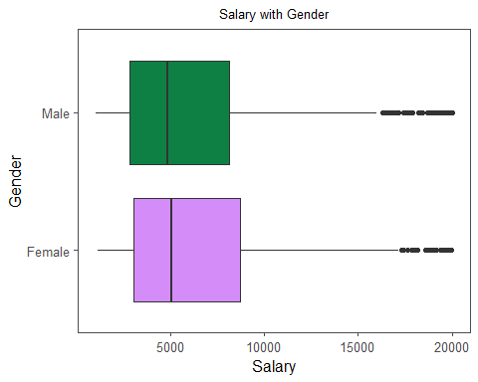

**Attrition Count With Gender**

ggplot(HRA,aes(MaritalStatus,..count..,fill=Attrition))+geom_bar(position=position_dodge())+theme_few()+theme(legend.position="bottom",plot.title=element_text(hjust=0.5,size=16))+labs(title="Attrition Count Vs Marital Status")

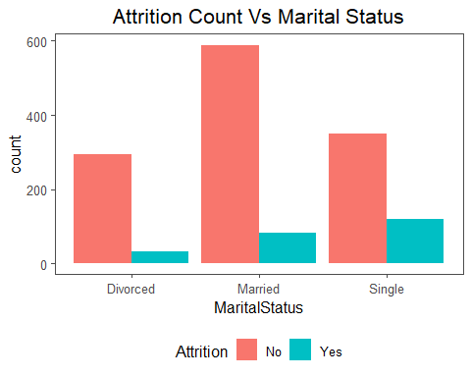

From the plot, it is understood that irrespective of the marital status, there are large people who stay with the company and do not leave. Therefore, marital status is a weak predictor of attrition.

**Attrition Level Comparision**

ggplot(HRA,aes(Age,MonthlyIncome,size=Age,col=factor(Attrition)))+geom_point(alpha=0.3)+theme_minimal()+facet_wrap(~MaritalStatus)+labs(x="Age",y="MonthlyIncome",title="Attrition Level Comparision ",subtitle="How attrition is observed with change in Age,Income and MaritalStatus",col="Attrition")+theme(legend.position="bottom",plot.title=element_text(size=16,hjust=0.5),plot.subtitle = element_text(size=10))+scale_color_brewer(palette="Set2")

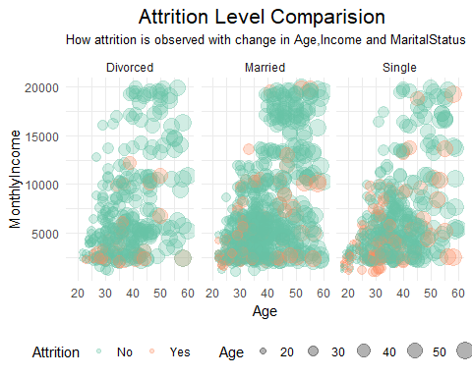

* The trend is linear for age and monthly income across the marital status.
* It is observed that attrition is more pronounced with “single” people across the age groups.
* Married people having lower salary attrite more whereas divorced people have not attrite much.

**Attrition vs department**

ggplot(HRA,aes(x=Department,group=Attrition))+geom_bar(aes(y=..prop..,fill=factor(..x..)),stat="count")+facet_grid(~Attrition)+theme(axis.text.x=element_text(angle=90,vjust=0.5),legend.position="none",plot.title=element_text(size=16,hjust=0.5))+labs(x="Department",y="Percentage",title="Attrition % Vs Department")+ geom_text(aes(label = scales::percent(..prop..), y = ..prop.. ),stat= "count",vjust =-.5)

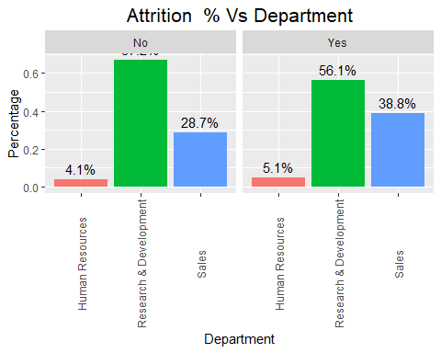

On comparing department wise, we can conclude that HR has seen only a marginal high in turnover rates whereas the numbers are significant in sales department with turnover rates of 39 %. The attrition levels are not appreciable in R & D where 67 % have recorded no attrition.

**Department Vs Attrition**

ggplot(HRA,aes(x=Attrition,group=Department))+geom_bar(aes(y=..prop..,fill=factor(..x..)),stat="count")+facet_grid(~Department)+theme(axis.text.x=element_text(angle=90,vjust=0.5),legend.position="none",plot.title=element_text(size=16,hjust=0.5))+labs(x="Attrition",y="Percentage",title="Department Vs Attrition %")+ geom_text(aes(label = scales::percent(..prop..), y = ..prop.. ),stat= "count",vjust =-.5)

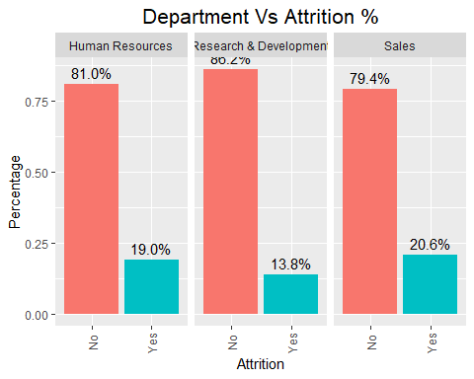

* Sales has seen higher attrition levels (about 20.6%) followed by HR(19%).

**Attrition Vs Distance From Home**

ggplot(HRA,aes(DistanceFromHome,fill=Attrition))+geom_density(alpha=0.5)+theme_few()+theme(legend.position="bottom",plot.title=element_text(hjust=0.5,size=16))+labs(x="Distance from Home",title="Attrition Vs Distance From Home")+scale_fill_canva(palette="Bold feature colors")

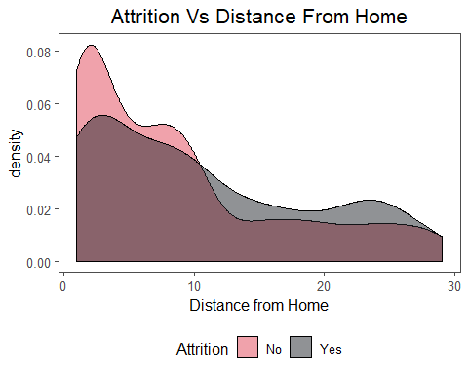

* There is a higher number of people who reside near to offices and hence the attrition levels are lower for distance <10 .With the increase in distance from home,the attrition curve overtakes the no attrition curve which is expected.

**Attrition Vs Business Travel**

ggplot(HRA,aes(BusinessTravel,fill=Attrition))+geom_bar(stat="count",aes(y=..count..),position=position_dodge())+theme_few()+theme(legend.position="bottom",plot.title=element_text(hjust=0.5,size=16),axis.text.x = element_text(angle=90))+labs(x="Travel Frequency",y="Count",title="Attrition Vs Business Travel")

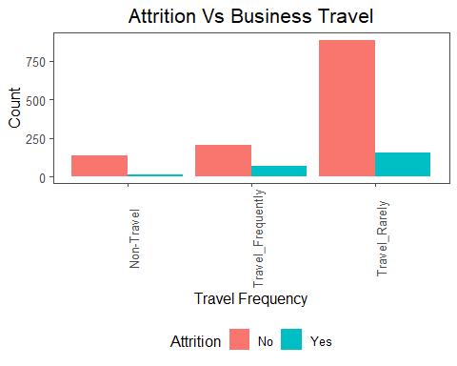

* There are more people who travel rarely compared to those who travel frequently. In all the 3 cases, the attrition is not significantly evident.

**Attrition Vs Payrates**

g1=ggplot(HRA,aes(Attrition,DailyRate,fill=Attrition))+geom_boxplot()+theme_few()+theme(plot.title=element_text(hjust=0.5),legend.position="bottom")+scale_y_continuous(limits=c(100,1500),breaks=seq(100,1500,100))+coord_flip()+labs(title="Attrition Vs Daily Wages")  
g1

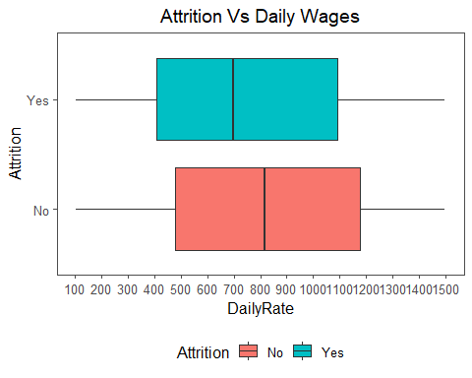

g2=ggplot(HRA,aes(Attrition,MonthlyIncome,fill=Attrition))+geom_boxplot()+theme_few()+theme(plot.title=element_text(hjust=0.5),legend.position="bottom")+coord_flip()+labs(title="Attrition Vs Monthly Income")  
g2

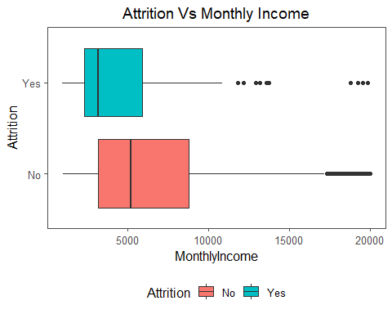

g3=ggplot(HRA,aes(Attrition,HourlyRate,fill=Attrition))+geom_boxplot()+theme_few()+theme(plot.title=element_text(hjust=0.5),legend.position="bottom")+coord_flip()+labs(title="Attrition Vs Hourly Wages")  
g3

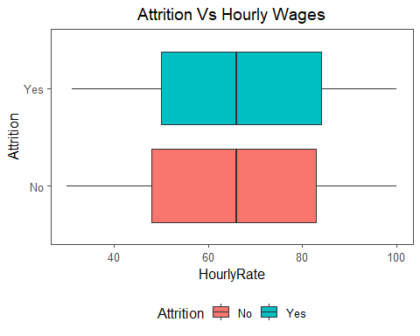

There is a difference between the attrition with daily rates. Attrition is present for lesser daily rates and there is no attrition for higher daily rates. The trend is resonating with monthly income too. Let us check with the hourly rates.

While the difference in the daily wages and the attrition is significant, this is not the case with hourly rates as seen from the boxplot.

**Percentage of Hike Vs Years of Experience**

ggplot(HRA,aes(TotalWorkingYears,PercentSalaryHike,col=factor(Attrition),size=PercentSalaryHike))+geom_point(alpha=0.6)+theme(legend.position="bottom",plot.title = element_text(size=15,hjust=0.5))+labs(title="Percentage of Hike Vs Years of Experience",col="Attrition")

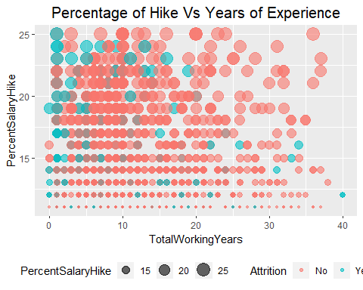

* From the graph, we see that there is no linear relationship between total working years and percentage of salary hike.
* People with lesser years of work experience have received 25 % of salary hike when they switch over but this pattern is not seen for people with higher work experience. After 20 years, attrition is not seen among people who received 25 % hike.
* As years of experience increases, those who switch over have actually received less than 20 % hike as the trend indicates.

**Years at Company Vs Percentage of Hike**

ggplot(HRA,aes(YearsAtCompany,PercentSalaryHike,size=PercentSalaryHike))+geom_point(color="purple",alpha=0.5)+theme_few()+theme(legend.position="none",plot.title=element_text(hjust=0.5,size=16))+labs(title="Years at Company Vs Percentage of Hike")

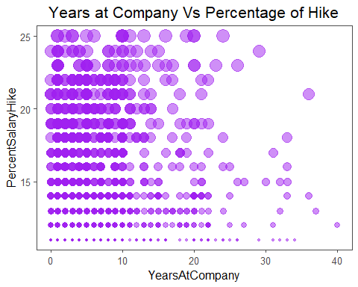

* Here too we see no relation between the two factors.Even People who have lesser year of stint at the company have received maximum hike.

**Which Role Gets Paid More?**

temp=HRA %>% group_by(JobRole) %>% summarise(salary=median(MonthlyIncome)) %>% arrange(desc(salary))  
ggplot(temp,aes(factor(JobRole,levels=JobRole),salary))+geom_bar(stat="identity",fill="gold4")+coord_polar()+labs(x="Job Role",y="Median Salary",title="Who gets more??")+theme_few()+theme(axis.text.x=element_text(vjust=300),plot.title=element_text(hjust=0.5,size=16),axis.text.y=element_blank())

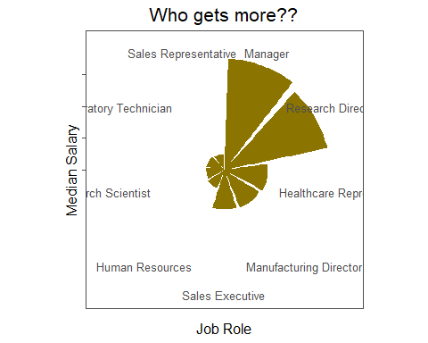

* Manager, Research director, Healthcare representative have higher median salary whereas HR, Sales rep have been paid a lower salary.

**Attrition Rate by Job Role**

ggplot(HRA,aes(x=reorder(JobRole,Attrition),y=Attrition)) + geom_bar(stat='identity',alpha=0.5,fill="red") + theme_fivethirtyeight()+coord_flip()+theme(axis.text.x=element_text(angle=0,vjust=0.5),legend.position='bottom',plot.title = element_text(size=12)) +labs(title="Attrition Rate by Job Role")

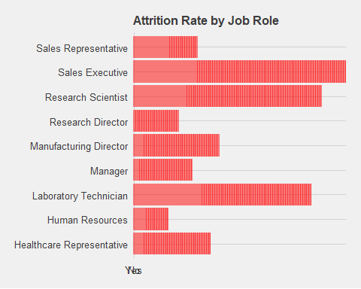

## 

**Trend of Attrition with Education Level:**

temp= HRA %>% mutate(Education=factor(Education)) %>% mutate(Education=fct_recode(Education,'Below College'='1','College'='2','Bachelor'='3','Master'='4','Doctor'='5'))  
ggplot(temp,aes(Education,fill=Attrition))+geom_bar(stat="count",aes(y=..count..),position=position_dodge())+theme_few()+theme_few()+theme(legend.position="bottom",plot.title=element_text(hjust=0.5,size=16),axis.text.x = element_text(angle=90))+labs(x="Education Level",y="Count",title="Trend of Attrition with Education Level")+scale_fill_canva(palette="Golden afternoon")

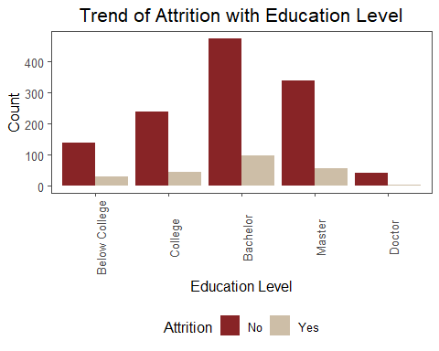

* There are more people with a bachelors degree followed by masters degree. It is seen that the attrition levels are not pronounced across education levels. Let us include the education field also and make the comparison.

**Education levels and field of education**

ggplot(temp,aes(Education,fill=Attrition))+geom_bar(stat="count",aes(y=..count..),position=position_dodge())+theme_few()+theme_few()+theme(legend.position="bottom",plot.title=element_text(hjust=0.5,size=16),axis.text.x = element_text(angle=90))+labs(x="Education Level",y="Count",title="Education levels and field of education")+scale_fill_canva(palette="Unique and striking")+facet_grid(~EducationField)

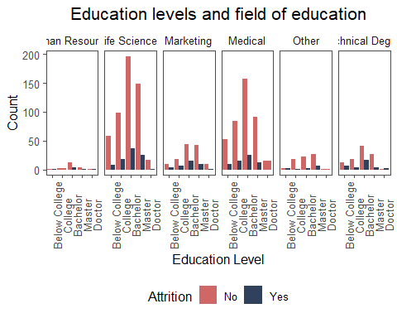

* Life sciences,Medical are represented more whereas HR is least represented.

**Education Vs Satisfaction Levels Vs Attrition:**

temp %>% mutate(JobSatisfaction=factor(JobSatisfaction)) %>% mutate(JobSatisfaction=fct_recode(JobSatisfaction,"Low"="1","Medium"="2","High"="3","Very High"="4")) %>% ggplot(aes(Education,fill=JobSatisfaction))+geom_bar(stat="count",position = position_dodge())+theme_few()+facet_wrap(~Attrition)+theme(legend.position="bottom",plot.title=element_text(hjust=0.5,size=16),axis.text.x = element_text(angle=90,hjust=0.5))+labs(x="Education",y="Satisfaction Count",title="Comparing attrition with Education")

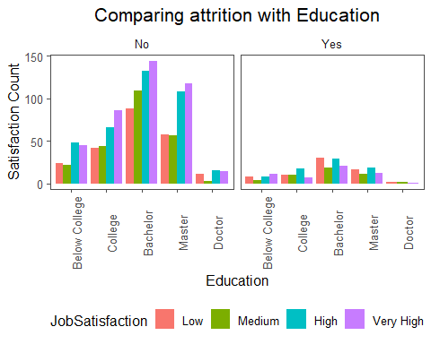

* The satisfaction levels are high as the education levels goes up under “No” attrition category.
* For people who attrite, the satisfaction levels are low as the education level goes up. Hence out assumption is valid.

**Number of companies worked:**

temp = HRA %>% group_by(Attrition,NumCompaniesWorked) %>% tally(sort=TRUE)  
ggplot(temp,aes(NumCompaniesWorked,n,fill=Attrition,label=n))+geom_bar(stat="identity",position=position_dodge())+theme_few()+theme(legend.position="bottom",plot.title=element_text(hjust=0.5,size=16))+labs(x="Number of Companies",y="Count",title="Number of Companies worked")+coord_cartesian(xlim=c(0,9))+scale_x_continuous(breaks=seq(0,9,1))

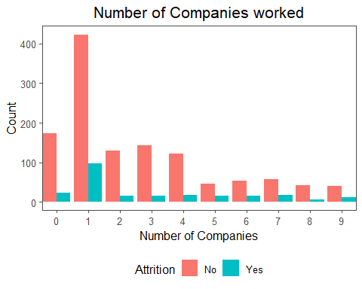

* There are more people who have changed only 1 company and the attrition level is not pronounced with change in companies.

**Attrition Trend With Number Of Years Of Experience**

g1=ggplot(HRA,aes(Attrition,TotalWorkingYears,fill=Attrition))+geom_boxplot()+theme(legend.position="bottom",plot.title=element_text(hjust=0.5))+labs(x="Attrition",y="Years of Experience",title="Attrition trend with number of years of experience")+coord_flip()  
g1

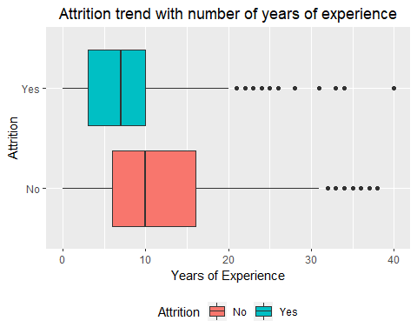

**Histogram of Years of experience Vs Attriton**

g2=HRA %>% filter(Attrition=="Yes") %>% ggplot(aes(TotalWorkingYears,..count..))+geom_histogram(binwidth=5,alpha=0.8,fill="#575da9")+labs(x="Years of Experience",y="Count",title="Histogram of Years of experience",subtitle="Attrition=Yes")+theme_few()+theme(plot.title=element_text(hjust=0.5),plot.subtitle=element_text(hjust=0.3))  
g2

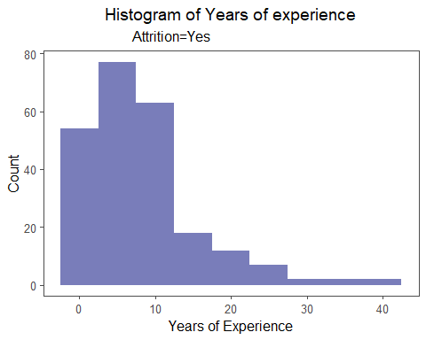

g3=HRA %>% filter(Attrition=="No") %>% ggplot(aes(TotalWorkingYears,..count..))+geom_histogram(binwidth=5,alpha=0.8,fill="#336b87")+labs(x="Years of Experience",y="Count",title="Histogram of Years of experience",subtitle="Attrition=No")+theme_few()+theme(plot.title=element_text(hjust=0.5),plot.subtitle=element_text(hjust=0.3))  
g3

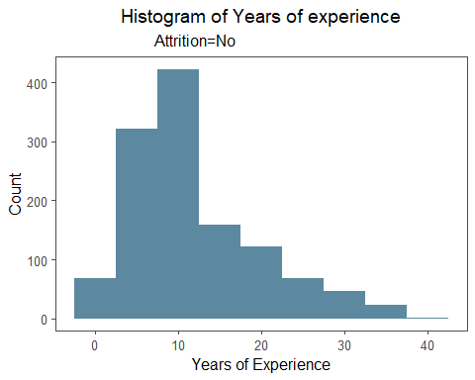

* Boxplot and histogram shows that there is a significant difference between the number of experience with attrition levels.
* It is noted that people with less than 10 years of experience prefer to jump to another company whereas after that the jump drops.
* The histogram for both the attrition levels is right skewed.

**Job Involvement Vs Attrition Rates**

temp = HRA %>% mutate(JobInvolvement=factor(JobInvolvement)) %>% mutate(JobInvolvement=fct_recode(JobInvolvement,"Low"="1","Medium"="2","High"="3","Very High"="4"))  
ggplot(temp,aes(x=JobInvolvement,group=Attrition))+geom_bar(stat="count",aes(y=..prop..,fill=factor(..x..)))+labs(x="Job Involvement",y="Percentage",title="Job Involvement Vs Attrition Rates")+facet_wrap(~Attrition)+theme_few()+theme(legend.position="none",plot.title=element_text(hjust=0.5,size=14))+geom_text(aes(label=scales::percent(..prop..),y=..prop..),stat="count",vjust=-0.5)

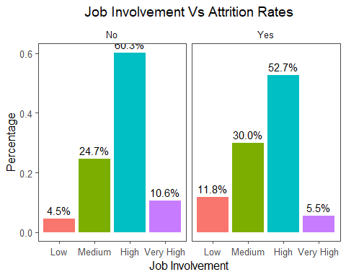

* People with **high** job involvement have higher attrition rates followed by **medium** involvement people. But, equal number of percentage of people have also shown no attrition rates.

**Job Satisfaction Vs Attrition Rates**

temp = HRA %>% mutate(JobSatisfaction=factor(JobSatisfaction)) %>% mutate(JobSatisfaction=fct_recode(JobSatisfaction,"Low"="1","Medium"="2","High"="3","Very High"="4"))  
ggplot(temp,aes(x=JobSatisfaction,group=Attrition))+geom_bar(stat="count",aes(y=..prop..,fill=factor(..x..)))+labs(x="Job Satisfaction",y="Percentage",title="Job Satisfaction Vs Attrition Rates")+facet_wrap(~Attrition)+theme_few()+theme(legend.position="none",plot.title=element_text(hjust=0.5,size=14))+geom_text(aes(label=scales::percent(..prop..),y=..prop..),stat="count",vjust=-0.5)

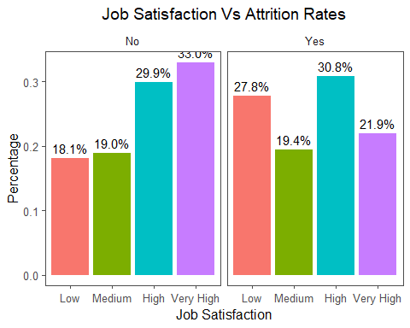

* As expected, people with low satisfaction have left the company (28 %) in large number. What is surprising is, out of those who leave about 30.8 % have experience high job satisfaction. Therefore, there should be some other factor which triggers their exit from the present company.
* There is a visible trend in the category of people who do not leave whereas this is not so in the case of people who leave. The attrition group is most represented by people having high and very high job satisfaction.

**Performance Rating Vs Attrition Rates:**

temp= HRA %>% mutate(PerformanceRating=factor(PerformanceRating)) %>% mutate(PerformanceRating=fct_recode(PerformanceRating,"Low"="1","Good"="2","Excellent"="3","Outstanding"="4"))

ggplot(temp,aes(x=PerformanceRating,group=Attrition))+geom_bar(stat="count",aes(y=..prop..,fill=factor(..x..)))+labs(x="PerformanceRating",y="Percentage",title="Performance Rating Vs Attrition Rates")+facet_wrap(~Attrition)+theme_few()+theme(legend.position="none",plot.title=element_text(hjust=0.5,size=14))+geom_text(aes(label=scales::percent(..prop..),y=..prop..),stat="count",vjust=-0.5)

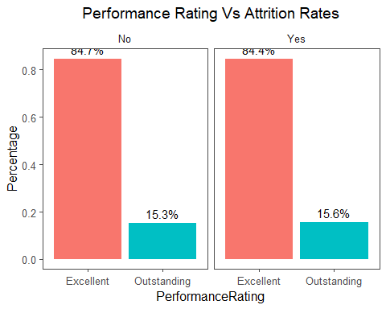

* Though there are 4 levels in performance rating, our dataset is represented only by 2 levels-Excellent and Outstanding. It may be seen that there is no difference between the performance rating and attrition levels. Both the groups have shown similar percentages.

**Relationship Satisfaction Vs Attrition Rates**

temp= HRA %>% mutate(RelationshipSatisfaction=factor(RelationshipSatisfaction)) %>% mutate(RelationshipSatisfaction=fct_recode(RelationshipSatisfaction,"Low"="1","Medium"="2","High"="3","Very High"="4"))  
ggplot(temp,aes(x=RelationshipSatisfaction,group=Attrition))+geom_bar(stat="count",aes(y=..prop..,fill=factor(..x..)))+labs(x="RelationshipSatisfaction",y="Percentage",title="RelationshipSatisfaction Vs Attrition Rates")+facet_wrap(~Attrition)+theme_few()+theme(legend.position="none",plot.title=element_text(hjust=0.5,size=14))+geom_text(aes(label=scales::percent(..prop..),y=..prop..),stat="count",vjust=-0.5)

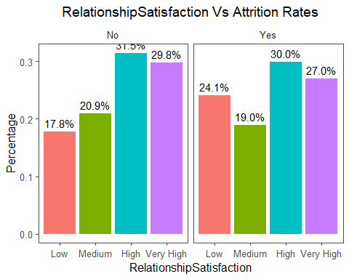

* In this too, we find that almost 57 % (combining high and very high) experience attrition whereas similar percentage have also stayed within the company.

**Work life balance Vs Attrition Rates**

temp= HRA %>% mutate(WorkLifeBalance=factor(WorkLifeBalance)) %>% mutate(WorkLifeBalance=fct_recode(WorkLifeBalance,"Bad"="1","Good"="2","Better"="3","Best"="4"))  
ggplot(temp,aes(x=WorkLifeBalance,group=Attrition))+geom_bar(stat="count",aes(y=..prop..,fill=factor(..x..)))+labs(x="WorkLifeBalance",y="Percentage",title="Worklifebalance Vs Attrition Rates")+facet_wrap(~Attrition)+theme_few()+theme(legend.position="none",plot.title=element_text(hjust=0.5,size=14))+geom_text(aes(label=scales::percent(..prop..),y=..prop..),stat="count",vjust=-0.5)

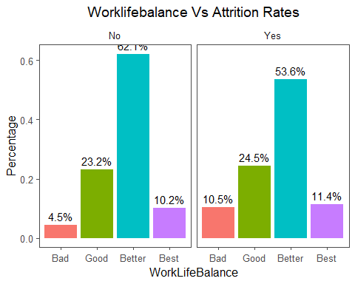

* As seen with the other categorical variables, here too we find that people having better work life balance leave the company whereas about 60 % who have experienced better work life balance stay with the company. We now continue with our last categorical variable-Environment satisfaction.

**Environment Satisfaction Vs Attrition Rates:**

temp= HRA %>% mutate(EnvironmentSatisfaction=factor(EnvironmentSatisfaction)) %>% mutate(EnvironmentSatisfaction=fct_recode(EnvironmentSatisfaction,"Low"="1","Medium"="2","High"="3","Very High"="4"))  
ggplot(temp,aes(x=EnvironmentSatisfaction,group=Attrition))+geom_bar(stat="count",aes(y=..prop..,fill=factor(..x..)))+labs(x="EnvironmentSatisfaction",y="Percentage",title="Environment satisfaction Vs Attrition Rates")+facet_wrap(~Attrition)+theme_few()+theme(legend.position="none",plot.title=element_text(hjust=0.5,size=14))+geom_text(aes(label=scales::percent(..prop..),y=..prop..),stat="count",vjust=-0.5)

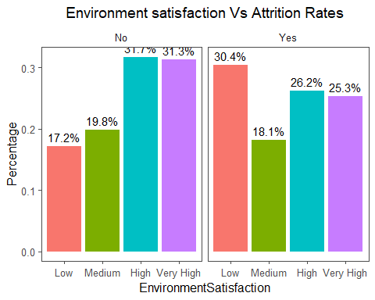

* Here we see that people having low environment satisfaction ( 30.4%) leave the company.

**Overtime Vs Attrition Rates**

ggplot(HRA,aes(x=OverTime,group=Attrition))+geom_bar(stat="count",aes(y=..prop..,fill=factor(..x..)))+labs(x="Overtime",y="Percentage",title="Overtime Vs Attrition Rates")+facet_wrap(~Attrition)+theme_few()+theme(legend.position="none",plot.title=element_text(hjust=0.5,size=14))+geom_text(aes(label=scales::percent(..prop..),y=..prop..),stat="count",vjust=-0.5)

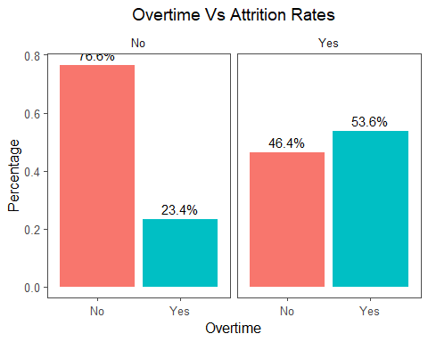

* 53 % of those who experience attrition have worked overtime whereas 76 % of those who have not experienced overtime have not left the company.Therefore overtime is a strong indicator of attrition.
* **Data Imbalance:**

table(HRA1$Attrition)

##   
## No Yes   
## 1233 237

library(ggplot2)  
ggplot(HRA1, aes(x=Attrition)) + ggtitle("Attrition") + xlab("Attrition") +  
 geom_bar(aes(y = 100*(..count..)/sum(..count..)), width = 0.5) + ylab("Count") + coord_flip() + theme_minimal()

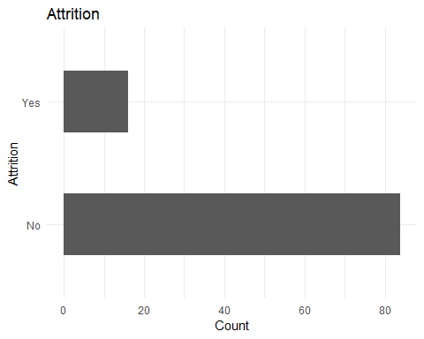

The dependent variable Attrition is imbalanced. This may effect the accuracy of prediction. Since we have already noted the severe imbalance in the values within the target variable, let us implement the SMOTE method in the dealing with this skewed value

Classcount = table(HRA1$Attrition)  
# Over Sampling  
over = ( (0.6 * max(Classcount)) - min(Classcount) ) / min(Classcount)  
# Under Sampling  
under = (0.4 * max(Classcount)) / (min(Classcount) * over)  
  
over = round(over, 1) * 100  
under = round(under, 1) * 100  
#Generate the balanced data set  
  
library(DMwR)

## Loading required package: lattice

## Loading required package: grid

HRA = SMOTE(Attrition~., HRA1, perc.over = 210, k = 5, perc.under = 100)  
View(HRA)

table(HRA$Attrition)

##   
## No Yes   
## 474 711

library(ggplot2)  
ggplot(HRA, aes(x=Attrition)) + ggtitle("Attrition") + xlab("Attrition") +  
 geom_bar(aes(y = 100*(..count..)/sum(..count..)), width = 0.5) + ylab("Count") + coord_flip() + theme_minimal()

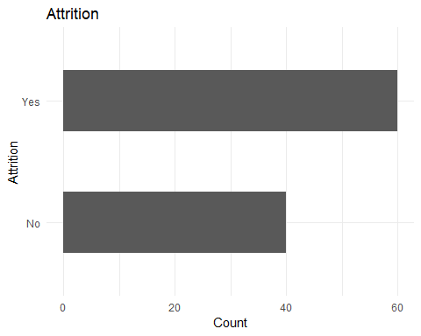

* **Feature Selection**

Removing Insignificant Varaibles

HRA$EmployeeNumber<-NULL  
HRA$StandardHours<-NULL  
HRA$Over18<-NULL

HRA$EmployeeCount<-NULL

## 2.2 Phase III - Feature Engineering

HRA$TotlaSatisfaction <-   
 as.numeric(HRA$EnvironmentSatisfaction)+  
 as.numeric(HRA$JobInvolvement)+  
 as.numeric(HRA$JobSatisfaction)+  
 as.numeric(HRA$RelationshipSatisfaction)+  
 as.numeric(HRA$WorkLifeBalance)  
  
HRA <- HRA[,-c(9,12,15,23,27)]  
  
summary(HRA)

## Age Attrition BusinessTravel DailyRate   
## Min. :18.00 No :474 Non-Travel : 76 Min. : 102.0   
## 1st Qu.:30.00 Yes:711 Travel_Frequently:249 1st Qu.: 513.5   
## Median :34.04 Travel_Rarely :860 Median : 810.0   
## Mean :35.44 Mean : 806.5   
## 3rd Qu.:40.00 3rd Qu.:1147.4   
## Max. :60.00 Max. :1496.0   
##   
## Department DistanceFromHome Education  
## Human Resources : 40 Min. : 1.000 1:194   
## Research & Development:776 1st Qu.: 3.487 2:235   
## Sales :369 Median : 8.243 3:421   
## Mean : 9.971 4:303   
## 3rd Qu.:15.000 5: 32   
## Max. :29.000   
##   
## EducationField Gender HourlyRate JobLevel  
## Human Resources : 24 Female:423 Min. : 30.00 1:665   
## Life Sciences :520 Male :762 1st Qu.: 53.43 2:299   
## Marketing :118 Median : 71.00 3:133   
## Medical :319 Mean : 68.47 4: 55   
## Other : 96 3rd Qu.: 84.00 5: 33   
## Technical Degree:108 Max. :100.00   
##   
## JobRole MaritalStatus MonthlyIncome   
## Research Scientist :289 Divorced:173 Min. : 1009   
## Laboratory Technician :280 Married :390 1st Qu.: 2632   
## Sales Executive :219 Single :622 Median : 3778   
## Sales Representative :127 Mean : 5212   
## Healthcare Representative: 79 3rd Qu.: 5993   
## Manufacturing Director : 72 Max. :19999   
## (Other) :119   
## MonthlyRate NumCompaniesWorked OverTime PercentSalaryHike  
## Min. : 2125 Min. :0.000 No :685 Min. :11.00   
## 1st Qu.: 7710 1st Qu.:1.000 Yes:500 1st Qu.:12.86   
## Median :12862 Median :2.176 Median :14.37   
## Mean :13245 Mean :3.000 Mean :15.51   
## 3rd Qu.:18275 3rd Qu.:4.841 3rd Qu.:18.00   
## Max. :26999 Max. :9.000 Max. :25.00   
##   
## PerformanceRating StockOptionLevel TotalWorkingYears  
## 3:948 0:724 Min. : 0.000   
## 4:237 1:305 1st Qu.: 6.000   
## 2: 91 Median : 8.000   
## 3: 65 Mean : 9.737   
## 3rd Qu.:11.486   
## Max. :40.000   
##   
## TrainingTimesLastYear YearsAtCompany YearsInCurrentRole  
## Min. :0.000 Min. : 0.000 Min. : 0.000   
## 1st Qu.:2.000 1st Qu.: 2.372 1st Qu.: 1.366   
## Median :3.000 Median : 4.687 Median : 2.000   
## Mean :2.862 Mean : 5.996 Mean : 3.373   
## 3rd Qu.:3.582 3rd Qu.: 8.000 3rd Qu.: 4.780   
## Max. :6.000 Max. :40.000 Max. :18.000   
##   
## YearsSinceLastPromotion YearsWithCurrManager TotlaSatisfaction  
## Min. : 0.000 Min. : 0.000 Min. : 6.00   
## 1st Qu.: 0.000 1st Qu.: 1.452 1st Qu.:11.69   
## Median : 1.000 Median : 2.846 Median :13.00   
## Mean : 1.972 Mean : 3.617 Mean :12.97   
## 3rd Qu.: 2.301 3rd Qu.: 6.000 3rd Qu.:14.00   
## Max. :15.000 Max. :17.000 Max. :19.00   
##

HRA$AgeGroup <- as.factor(  
 ifelse(HRA$Age<=24,"Young", ifelse(  
 HRA$Age<=54,"Middle-Age","Adult"  
 ))  
)  
HRA <- HRA[,-c(1)]  
  
table(HRA$AgeGroup)

##   
## Adult Middle-Age Young   
## 44 1051 90

HRA$Incomelevel <- as.factor(  
 ifelse(HRA$MonthlyIncome<ave(HRA$MonthlyIncome),"Low","High")  
)  
table(HRA$Incomelevel)

##   
## High Low   
## 397 788

summary(HRA)

## Attrition BusinessTravel DailyRate   
## No :474 Non-Travel : 76 Min. : 102.0   
## Yes:711 Travel_Frequently:249 1st Qu.: 513.5   
## Travel_Rarely :860 Median : 810.0   
## Mean : 806.5   
## 3rd Qu.:1147.4   
## Max. :1496.0   
##   
## Department DistanceFromHome Education  
## Human Resources : 40 Min. : 1.000 1:194   
## Research & Development:776 1st Qu.: 3.487 2:235   
## Sales :369 Median : 8.243 3:421   
## Mean : 9.971 4:303   
## 3rd Qu.:15.000 5: 32   
## Max. :29.000   
##   
## EducationField Gender HourlyRate JobLevel  
## Human Resources : 24 Female:423 Min. : 30.00 1:665   
## Life Sciences :520 Male :762 1st Qu.: 53.43 2:299   
## Marketing :118 Median : 71.00 3:133   
## Medical :319 Mean : 68.47 4: 55   
## Other : 96 3rd Qu.: 84.00 5: 33   
## Technical Degree:108 Max. :100.00   
##   
## JobRole MaritalStatus MonthlyIncome   
## Research Scientist :289 Divorced:173 Min. : 1009   
## Laboratory Technician :280 Married :390 1st Qu.: 2632   
## Sales Executive :219 Single :622 Median : 3778   
## Sales Representative :127 Mean : 5212   
## Healthcare Representative: 79 3rd Qu.: 5993   
## Manufacturing Director : 72 Max. :19999   
## (Other) :119   
## MonthlyRate NumCompaniesWorked OverTime PercentSalaryHike  
## Min. : 2125 Min. :0.000 No :685 Min. :11.00   
## 1st Qu.: 7710 1st Qu.:1.000 Yes:500 1st Qu.:12.86   
## Median :12862 Median :2.176 Median :14.37   
## Mean :13245 Mean :3.000 Mean :15.51   
## 3rd Qu.:18275 3rd Qu.:4.841 3rd Qu.:18.00   
## Max. :26999 Max. :9.000 Max. :25.00   
##   
## PerformanceRating StockOptionLevel TotalWorkingYears  
## 3:948 0:724 Min. : 0.000   
## 4:237 1:305 1st Qu.: 6.000   
## 2: 91 Median : 8.000   
## 3: 65 Mean : 9.737   
## 3rd Qu.:11.486   
## Max. :40.000   
##   
## TrainingTimesLastYear YearsAtCompany YearsInCurrentRole  
## Min. :0.000 Min. : 0.000 Min. : 0.000   
## 1st Qu.:2.000 1st Qu.: 2.372 1st Qu.: 1.366   
## Median :3.000 Median : 4.687 Median : 2.000   
## Mean :2.862 Mean : 5.996 Mean : 3.373   
## 3rd Qu.:3.582 3rd Qu.: 8.000 3rd Qu.: 4.780   
## Max. :6.000 Max. :40.000 Max. :18.000   
##   
## YearsSinceLastPromotion YearsWithCurrManager TotlaSatisfaction  
## Min. : 0.000 Min. : 0.000 Min. : 6.00   
## 1st Qu.: 0.000 1st Qu.: 1.452 1st Qu.:11.69   
## Median : 1.000 Median : 2.846 Median :13.00   
## Mean : 1.972 Mean : 3.617 Mean :12.97   
## 3rd Qu.: 2.301 3rd Qu.: 6.000 3rd Qu.:14.00   
## Max. :15.000 Max. :17.000 Max. :19.00   
##   
## AgeGroup Incomelevel  
## Adult : 44 High:397   
## Middle-Age:1051 Low :788   
## Young : 90

## 2.3 Exploratory Data Analysis:

**Converting Numeric Data as.factor**

HRA1$Education <- as.factor(HRA1$Education)  
HRA1$JobLevel <- as.factor(HRA1$JobLevel)  
HRA1$PerformanceRating <- as.factor(HRA1$PerformanceRating)  
HRA1$StockOptionLevel <- as.factor(HRA1$StockOptionLevel)

HRA <- HRA1

**Removing Insignificant Variables:**

HRA$EmployeeNumber<- NULL  
HRA$StandardHours <- NULL  
HRA$Over18 <- NULL  
HRA$EmployeeCount <- NULL  
  
summary(HRA)

## Age Attrition BusinessTravel DailyRate   
## Min. :18.00 No :474 Non-Travel : 76 Min. : 102.0   
## 1st Qu.:30.00 Yes:711 Travel_Frequently:249 1st Qu.: 513.5   
## Median :34.04 Travel_Rarely :860 Median : 810.0   
## Mean :35.44 Mean : 806.5   
## 3rd Qu.:40.00 3rd Qu.:1147.4   
## Max. :60.00 Max. :1496.0   
##   
## Department DistanceFromHome Education  
## Human Resources : 40 Min. : 1.000 1:194   
## Research & Development:776 1st Qu.: 3.487 2:235   
## Sales :369 Median : 8.243 3:421   
## Mean : 9.971 4:303   
## 3rd Qu.:15.000 5: 32   
## Max. :29.000   
##   
## EducationField EnvironmentSatisfaction Gender   
## Human Resources : 24 Min. :1.000 Female:423   
## Life Sciences :520 1st Qu.:2.000 Male :762   
## Marketing :118 Median :3.000   
## Medical :319 Mean :2.656   
## Other : 96 3rd Qu.:3.538   
## Technical Degree:108 Max. :4.000   
##   
## HourlyRate JobInvolvement JobLevel JobRole   
## Min. : 30.00 Min. :1.000 1:665 Research Scientist :289   
## 1st Qu.: 53.43 1st Qu.:2.000 2:299 Laboratory Technician :280   
## Median : 71.00 Median :2.811 3:133 Sales Executive :219   
## Mean : 68.47 Mean :2.527 4: 55 Sales Representative :127   
## 3rd Qu.: 84.00 3rd Qu.:3.000 5: 33 Healthcare Representative: 79   
## Max. :100.00 Max. :4.000 Manufacturing Director : 72   
## (Other) :119   
## JobSatisfaction MaritalStatus MonthlyIncome MonthlyRate   
## Min. :1.000 Divorced:173 Min. : 1009 Min. : 2125   
## 1st Qu.:1.410 Married :390 1st Qu.: 2632 1st Qu.: 7710   
## Median :2.459 Single :622 Median : 3778 Median :12862   
## Mean :2.425 Mean : 5212 Mean :13245   
## 3rd Qu.:3.000 3rd Qu.: 5993 3rd Qu.:18275   
## Max. :4.000 Max. :19999 Max. :26999   
##   
## NumCompaniesWorked OverTime PercentSalaryHike PerformanceRating  
## Min. :0.000 No :685 Min. :11.00 3:948   
## 1st Qu.:1.000 Yes:500 1st Qu.:12.86 4:237   
## Median :2.176 Median :14.37   
## Mean :3.000 Mean :15.51   
## 3rd Qu.:4.841 3rd Qu.:18.00   
## Max. :9.000 Max. :25.00   
##   
## RelationshipSatisfaction StockOptionLevel TotalWorkingYears  
## Min. :1.000 0:724 Min. : 0.000   
## 1st Qu.:2.000 1:305 1st Qu.: 6.000   
## Median :2.693 2: 91 Median : 8.000   
## Mean :2.578 3: 65 Mean : 9.737   
## 3rd Qu.:3.000 3rd Qu.:11.486   
## Max. :4.000 Max. :40.000   
##   
## TrainingTimesLastYear WorkLifeBalance YearsAtCompany YearsInCurrentRole  
## Min. :0.000 Min. :1.000 Min. : 0.000 Min. : 0.000   
## 1st Qu.:2.000 1st Qu.:2.451 1st Qu.: 2.372 1st Qu.: 1.366   
## Median :3.000 Median :3.000 Median : 4.687 Median : 2.000   
## Mean :2.862 Mean :2.786 Mean : 5.996 Mean : 3.373   
## 3rd Qu.:3.582 3rd Qu.:3.000 3rd Qu.: 8.000 3rd Qu.: 4.780   
## Max. :6.000 Max. :4.000 Max. :40.000 Max. :18.000   
##   
## YearsSinceLastPromotion YearsWithCurrManager  
## Min. : 0.000 Min. : 0.000   
## 1st Qu.: 0.000 1st Qu.: 1.452   
## Median : 1.000 Median : 2.846   
## Mean : 1.972 Mean : 3.617   
## 3rd Qu.: 2.301 3rd Qu.: 6.000   
## Max. :15.000 Max. :17.000   
##

# 

# CHAPTER 3: FITTING MODELS TO DATA

**Splitting**

library(caTools)  
set.seed(010)  
splitHRA<-sample.split(HRA$Attrition, SplitRatio = 0.80)  
trainHRA<-subset(HRA,splitHRA==T)  
testHRA<-subset(HRA,splitHRA==F)

## 3.1 LOGISTIC REGRESSION MODEL

## 3.1.1 First Logistic Regression Model

modelHRAL12<-glm(Attrition~.,family=binomial(link="logit"),data=trainHRA)  
summary(modelHRAL12)

##   
## Call:  
## glm(formula = Attrition ~ ., family = binomial(link = "logit"),   
## data = trainHRA)  
##   
## Deviance Residuals:   
## Min 1Q Median 3Q Max   
## -3.0296 -0.2618 0.0984 0.4317 3.2918   
##   
## Coefficients:  
## Estimate Std. Error z value Pr(>|z|)  
## (Intercept) 2.016e+00 2.471e+00 0.816 0.414467  
## BusinessTravelTravel_Frequently 2.615e+00 5.750e-01 4.547 5.44e-06  
## BusinessTravelTravel_Rarely 2.160e+00 5.234e-01 4.127 3.68e-05  
## DailyRate -2.788e-05 3.060e-04 -0.091 0.927408  
## DepartmentResearch & Development 2.034e+00 1.316e+00 1.546 0.121998  
## DepartmentSales 2.581e+00 1.324e+00 1.949 0.051307  
## DistanceFromHome 8.914e-02 1.656e-02 5.381 7.39e-08  
## Education2 -8.597e-01 4.228e-01 -2.033 0.042009  
## Education3 -1.259e+00 3.692e-01 -3.411 0.000648  
## Education4 -9.924e-01 4.043e-01 -2.454 0.014110  
## Education5 -2.341e+00 8.341e-01 -2.807 0.005005  
## EducationFieldLife Sciences -9.013e-01 1.163e+00 -0.775 0.438311  
## EducationFieldMarketing -4.779e-02 1.224e+00 -0.039 0.968860  
## EducationFieldMedical -8.429e-01 1.162e+00 -0.725 0.468180  
## EducationFieldOther -9.747e-02 1.218e+00 -0.080 0.936212  
## EducationFieldTechnical Degree -1.688e-01 1.182e+00 -0.143 0.886401  
## GenderMale 8.936e-01 2.438e-01 3.665 0.000247  
## HourlyRate 3.746e-03 6.077e-03 0.616 0.537578  
## JobLevel2 -2.407e+00 3.997e-01 -6.022 1.73e-09  
## JobLevel3 -3.591e-01 5.875e-01 -0.611 0.541074  
## JobLevel4 -2.531e+00 1.099e+00 -2.303 0.021265  
## JobLevel5 2.174e+00 1.350e+00 1.610 0.107414  
## JobRoleHuman Resources 2.874e+00 1.575e+00 1.824 0.068087  
## JobRoleLaboratory Technician 1.112e+00 6.445e-01 1.725 0.084514  
## JobRoleManager -1.093e+00 1.256e+00 -0.870 0.384488  
## JobRoleManufacturing Director 9.951e-01 6.783e-01 1.467 0.142362  
## JobRoleResearch Director -1.986e+00 1.349e+00 -1.472 0.141119  
## JobRoleResearch Scientist 6.813e-01 6.367e-01 1.070 0.284649  
## JobRoleSales Executive 1.453e+00 7.213e-01 2.015 0.043898  
## JobRoleSales Representative 1.621e+00 7.848e-01 2.065 0.038881  
## MaritalStatusMarried 6.017e-01 3.543e-01 1.698 0.089443  
## MaritalStatusSingle 1.968e+00 4.326e-01 4.550 5.35e-06  
## MonthlyIncome -1.025e-05 9.614e-05 -0.107 0.915109  
## MonthlyRate -8.913e-06 1.701e-05 -0.524 0.600330  
## NumCompaniesWorked 3.172e-01 5.959e-02 5.322 1.03e-07  
## OverTimeYes 2.282e+00 2.769e-01 8.241 < 2e-16  
## PercentSalaryHike -6.794e-02 4.509e-02 -1.507 0.131881  
## PerformanceRating4 8.839e-01 4.486e-01 1.970 0.048802  
## StockOptionLevel1 -8.616e-01 3.221e-01 -2.675 0.007466  
## StockOptionLevel2 -8.145e-01 4.812e-01 -1.692 0.090564  
## StockOptionLevel3 -3.645e-01 5.964e-01 -0.611 0.541080  
## TotalWorkingYears -8.537e-02 3.767e-02 -2.267 0.023417  
## TrainingTimesLastYear -8.101e-02 9.717e-02 -0.834 0.404447  
## YearsAtCompany 1.599e-01 4.871e-02 3.284 0.001025  
## YearsInCurrentRole -2.368e-01 6.771e-02 -3.497 0.000470  
## YearsSinceLastPromotion 2.475e-01 6.001e-02 4.125 3.71e-05  
## YearsWithCurrManager -1.573e-01 6.460e-02 -2.435 0.014904  
## TotlaSatisfaction -5.542e-01 6.428e-02 -8.622 < 2e-16  
## AgeGroupMiddle-Age 3.151e-01 6.443e-01 0.489 0.624860  
## AgeGroupYoung -1.029e-01 8.007e-01 -0.128 0.897759  
## IncomelevelLow 3.976e-01 4.701e-01 0.846 0.397691  
##   
## (Intercept)   
## BusinessTravelTravel_Frequently ***  
## BusinessTravelTravel_Rarely ***  
## DailyRate   
## DepartmentResearch & Development   
## DepartmentSales .   
## DistanceFromHome ***  
## Education2 *   
## Education3 ***  
## Education4 *   
## Education5 **   
## EducationFieldLife Sciences   
## EducationFieldMarketing   
## EducationFieldMedical   
## EducationFieldOther   
## EducationFieldTechnical Degree   
## GenderMale ***  
## HourlyRate   
## JobLevel2 ***  
## JobLevel3   
## JobLevel4 *   
## JobLevel5   
## JobRoleHuman Resources .   
## JobRoleLaboratory Technician .   
## JobRoleManager   
## JobRoleManufacturing Director   
## JobRoleResearch Director   
## JobRoleResearch Scientist   
## JobRoleSales Executive *   
## JobRoleSales Representative *   
## MaritalStatusMarried .   
## MaritalStatusSingle ***  
## MonthlyIncome   
## MonthlyRate   
## NumCompaniesWorked ***  
## OverTimeYes ***  
## PercentSalaryHike   
## PerformanceRating4 *   
## StockOptionLevel1 **   
## StockOptionLevel2 .   
## StockOptionLevel3   
## TotalWorkingYears *   
## TrainingTimesLastYear   
## YearsAtCompany **   
## YearsInCurrentRole ***  
## YearsSinceLastPromotion ***  
## YearsWithCurrManager *   
## TotlaSatisfaction ***  
## AgeGroupMiddle-Age   
## AgeGroupYoung   
## IncomelevelLow   
## ---  
## Signif. codes: 0 '***' 0.001 '**' 0.01 '*' 0.05 '.' 0.1 ' ' 1  
##   
## (Dispersion parameter for binomial family taken to be 1)  
##   
## Null deviance: 1275.87 on 947 degrees of freedom  
## Residual deviance: 540.49 on 897 degrees of freedom  
## AIC: 642.49  
##   
## Number of Fisher Scoring iterations: 6

## 3.1.2 Model Validation

3.1.2.1 Checking for Variance inflation (Multicollinearity)

**Bi-Variate Analysis:**

library(corrplot)  
corrplot(cor(sapply(HRA,as.integer)),method = "pie")



## 3.1.3 Second Logistic Regression model

modelHRAL13<-glm(Attrition~BusinessTravel+DistanceFromHome+JobRole+MaritalStatus+NumCompaniesWorked+OverTime+TotalWorkingYears+YearsAtCompany+YearsInCurrentRole+YearsSinceLastPromotion+TotlaSatisfaction,family=binomial(link="logit"),data=trainHRA)  
summary(modelHRAL13)

##   
## Call:  
## glm(formula = Attrition ~ BusinessTravel + DistanceFromHome +   
## JobRole + MaritalStatus + NumCompaniesWorked + OverTime +   
## TotalWorkingYears + YearsAtCompany + YearsInCurrentRole +   
## YearsSinceLastPromotion + TotlaSatisfaction, family = binomial(link = "logit"),   
## data = trainHRA)  
##   
## Deviance Residuals:   
## Min 1Q Median 3Q Max   
## -2.6953 -0.4820 0.1952 0.5388 2.9371   
##   
## Coefficients:  
## Estimate Std. Error z value Pr(>|z|)   
## (Intercept) 0.48806 0.93271 0.523 0.600789   
## BusinessTravelTravel_Frequently 2.25745 0.48226 4.681 2.86e-06 ***  
## BusinessTravelTravel_Rarely 2.19439 0.44206 4.964 6.91e-07 ***  
## DistanceFromHome 0.06143 0.01388 4.426 9.59e-06 ***  
## JobRoleHuman Resources 2.10885 0.60648 3.477 0.000507 ***  
## JobRoleLaboratory Technician 1.88042 0.46438 4.049 5.14e-05 ***  
## JobRoleManager -0.04109 0.70596 -0.058 0.953580   
## JobRoleManufacturing Director 0.16427 0.53403 0.308 0.758382   
## JobRoleResearch Director -0.61961 0.88903 -0.697 0.485838   
## JobRoleResearch Scientist 1.44657 0.45384 3.187 0.001435 **   
## JobRoleSales Executive 1.25956 0.46383 2.716 0.006616 **   
## JobRoleSales Representative 2.45065 0.52813 4.640 3.48e-06 ***  
## MaritalStatusMarried 0.62182 0.29163 2.132 0.032989 *   
## MaritalStatusSingle 2.23160 0.29902 7.463 8.45e-14 ***  
## NumCompaniesWorked 0.26132 0.04976 5.252 1.51e-07 ***  
## OverTimeYes 1.71456 0.21546 7.958 1.75e-15 ***  
## TotalWorkingYears -0.08720 0.02653 -3.287 0.001013 **   
## YearsAtCompany 0.07516 0.03844 1.955 0.050533 .   
## YearsInCurrentRole -0.25930 0.05329 -4.866 1.14e-06 ***  
## YearsSinceLastPromotion 0.22178 0.04834 4.588 4.47e-06 ***  
## TotlaSatisfaction -0.45675 0.05203 -8.779 < 2e-16 ***  
## ---  
## Signif. codes: 0 '***' 0.001 '**' 0.01 '*' 0.05 '.' 0.1 ' ' 1  
##   
## (Dispersion parameter for binomial family taken to be 1)  
##   
## Null deviance: 1275.87 on 947 degrees of freedom  
## Residual deviance: 685.21 on 927 degrees of freedom  
## AIC: 727.21  
##   
## Number of Fisher Scoring iterations: 6

## 3.1.4 Comparison of Linear Regression model

**Prediction:**

fitted.resultsHRAL13 <- predict(modelHRAL12,newdata=testHRA[,-1],type='response')

**Thresholding:**

fitted.resultsHRAL13<- ifelse(fitted.resultsHRAL13 > 0.5,1,0)

**Plotting AUC Curve:**

HRALP13 <- predict(modelHRAL12, newdata=testHRA[,-1], type="response")  
HRALpr13 <- prediction(fitted.resultsHRAL13, testHRA[,1])  
HRALprf13 <- performance(HRALpr13, measure = "tpr", x.measure = "fpr")  
plot(HRALprf13)

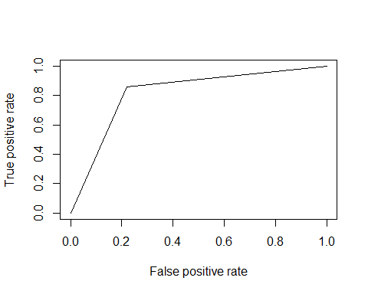

**Accuracy**:

HRALaucp13 <- performance(HRALpr13, measure = "auc")  
HRALaucp13 <- HRALaucp13@y.values[[1]]  
HRALaucp13

## [1] 0.8190511

# 3.2 DECESION TREE

## 3.2.1 Decision Tree model

library(rpart)  
modelHRADT2 <- rpart(formula = Attrition ~., data=trainHRA)  
plot(modelHRADT2)  
text(modelHRADT2)

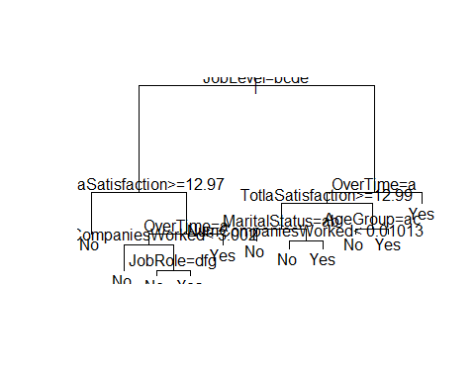

## 3.2.2 Decision Tree Prediction

HRADT2_pred = predict(modelHRADT2, newdata = testHRA, type = 'class')

**Confusion Matrix:**

## 3.2.3 Decision Tree Confusion Matrix

cmHRADT2 = table(HRADT2_pred, testHRA$Attrition)  
library(caret)  
cfHRADT2<-confusionMatrix(HRADT2_pred,testHRA$Attrition)  
cfHRADT2

## Confusion Matrix and Statistics  
##   
## Reference  
## Prediction No Yes  
## No 74 45  
## Yes 21 97  
##   
## Accuracy : 0.7215   
## 95% CI : (0.6598, 0.7776)  
## No Information Rate : 0.5992   
## P-Value [Acc > NIR] : 5.703e-05   
##   
## Kappa : 0.4435   
## Mcnemar's Test P-Value : 0.004639   
##   
## Sensitivity : 0.7789   
## Specificity : 0.6831   
## Pos Pred Value : 0.6218   
## Neg Pred Value : 0.8220   
## Prevalence : 0.4008   
## Detection Rate : 0.3122   
## Detection Prevalence : 0.5021   
## Balanced Accuracy : 0.7310   
##   
## 'Positive' Class : No   
##

## 3.2.4 Plotting AUC Curce

Raw.dt.plot<- plot.roc(as.numeric(testHRA$Attrition), as.numeric(HRADT2_pred),lwd=2, type="b",print.auc=TRUE,col ="blue")

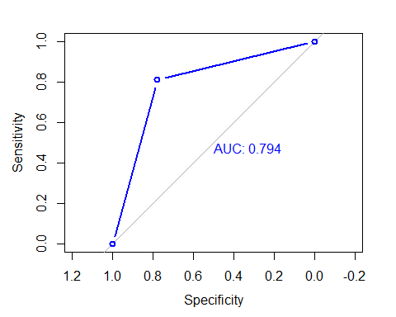

# 3.3 RANDOM FOREST

We applied Random Forest on the Training data set to validate if any further improvement of the model can be performed post the linear regression. Below were the parameters which were applied for Random Forest

## 3.3.1 Random Forest model

library(randomForest)

randomforestHRA2 = randomForest(x = trainHRA[-1],y = trainHRA$Attrition, ntree = 50)

## 3.3.2 Random Forest Model Prediction

randomHRA_pred2 = predict(randomforestHRA2,newdata = testHRA[-1])

## 3.3.3 Random Forest model Confusion Matrix

cmHRArandom2 = table(testHRA$Attrition,randomHRA_pred2)  
cmHRArandom2

## randomHRA_pred2  
## No Yes  
## No 83 12  
## Yes 19 123

library(caret)  
cfHRARF2<-confusionMatrix(randomHRA_pred2,testHRA$Attrition)  
cfHRARF2

## Confusion Matrix and Statistics  
##   
## Reference  
## Prediction No Yes  
## No 83 19  
## Yes 12 123  
##   
## Accuracy : 0.8692   
## 95% CI : (0.8195, 0.9094)  
## No Information Rate : 0.5992   
## P-Value [Acc > NIR] : <2e-16   
##   
## Kappa : 0.731   
## Mcnemar's Test P-Value : 0.2812   
##   
## Sensitivity : 0.8737   
## Specificity : 0.8662   
## Pos Pred Value : 0.8137   
## Neg Pred Value : 0.9111   
## Prevalence : 0.4008   
## Detection Rate : 0.3502   
## Detection Prevalence : 0.4304   
## Balanced Accuracy : 0.8699   
##   
## 'Positive' Class : No   
##

## 3.3.4 Random Forest model AUC Curve:

Raw.rf.plot<- plot.roc(as.numeric(testHRA$Attrition), as.numeric(Raw.rf.prd),lwd=2, type="b",print.auc=TRUE,col ="blue")

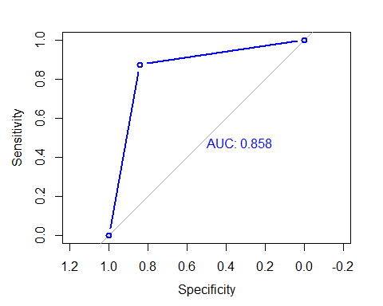

# 3.4 SVM

## 3.4.1 SVM tuning

library(e1071)  
  
# SVM based based on grid scearch  
tunesvmHRA=tune(svm,Attrition~.,  
 data=trainHRA,  
 ranges = list(gamma=2^(-1:1),cost=2^(2:9)))  
summary(tunesvmHRA)

##   
## Parameter tuning of 'svm':  
##   
## - sampling method: 10-fold cross validation   
##   
## - best parameters:  
## gamma cost  
## 0.5 4  
##   
## - best performance: 0.2921053   
##   
## - Detailed performance results:  
## gamma cost error dispersion  
## 1 0.5 4 0.2921053 0.03614142  
## 2 1.0 4 0.2921053 0.03614142  
## 3 2.0 4 0.2921053 0.03614142  
## 4 0.5 8 0.2921053 0.03614142  
## 5 1.0 8 0.2921053 0.03614142  
## 6 2.0 8 0.2921053 0.03614142  
## 7 0.5 16 0.2921053 0.03614142  
## 8 1.0 16 0.2921053 0.03614142  
## 9 2.0 16 0.2921053 0.03614142  
## 10 0.5 32 0.2921053 0.03614142  
## 11 1.0 32 0.2921053 0.03614142  
## 12 2.0 32 0.2921053 0.03614142  
## 13 0.5 64 0.2921053 0.03614142  
## 14 1.0 64 0.2921053 0.03614142  
## 15 2.0 64 0.2921053 0.03614142  
## 16 0.5 128 0.2921053 0.03614142  
## 17 1.0 128 0.2921053 0.03614142  
## 18 2.0 128 0.2921053 0.03614142  
## 19 0.5 256 0.2921053 0.03614142  
## 20 1.0 256 0.2921053 0.03614142  
## 21 2.0 256 0.2921053 0.03614142  
## 22 0.5 512 0.2921053 0.03614142  
## 23 1.0 512 0.2921053 0.03614142  
## 24 2.0 512 0.2921053 0.03614142

**Model Building:**

## 3.4.2 SVM model Building with Different Kernals

HRAclassifier10<-svm(formula =Attrition~.,data=trainHRA,type = 'C-classification')  
summary(HRAclassifier10)

##   
## Call:  
## svm(formula = Attrition ~ ., data = trainHRA, type = "C-classification")  
##   
##   
## Parameters:  
## SVM-Type: C-classification   
## SVM-Kernel: radial   
## cost: 1   
## gamma: 0.01960784   
##   
## Number of Support Vectors: 474  
##   
## ( 237 237 )  
##   
##   
## Number of Classes: 2   
##   
## Levels:   
## No Yes

HRAclassifier11<-svm(formula =Attrition~.,data=trainHRA,type = 'C-classification',gamma=0.5,cost=4)  
summary(HRAclassifier11)

##   
## Call:  
## svm(formula = Attrition ~ ., data = trainHRA, type = "C-classification",   
## gamma = 0.5, cost = 4)  
##   
##   
## Parameters:  
## SVM-Type: C-classification   
## SVM-Kernel: radial   
## cost: 4   
## gamma: 0.5   
##   
## Number of Support Vectors: 868  
##   
## ( 321 547 )  
##   
##   
## Number of Classes: 2   
##   
## Levels:   
## No Yes

HRAclassifier12<-svm(formula =Attrition~.,data=trainHRA,type = 'C-classification',kernel="linear")  
summary(HRAclassifier12)

##   
## Call:  
## svm(formula = Attrition ~ ., data = trainHRA, type = "C-classification",   
## kernel = "linear")  
##   
##   
## Parameters:  
## SVM-Type: C-classification   
## SVM-Kernel: linear   
## cost: 1   
## gamma: 0.01960784   
##   
## Number of Support Vectors: 323  
##   
## ( 161 162 )  
##   
##   
## Number of Classes: 2   
##   
## Levels:   
## No Yes

HRAclassifier13<-svm(formula =Attrition~.,data=trainHRA,type = 'C-classification',kernel="sigmoid")  
summary(HRAclassifier13)

##   
## Call:  
## svm(formula = Attrition ~ ., data = trainHRA, type = "C-classification",   
## kernel = "sigmoid")  
##   
##   
## Parameters:  
## SVM-Type: C-classification   
## SVM-Kernel: sigmoid   
## cost: 1   
## gamma: 0.01960784   
## coef.0: 0   
##   
## Number of Support Vectors: 472  
##   
## ( 237 235 )  
##   
##   
## Number of Classes: 2   
##   
## Levels:   
## No Yes

HRAclassifier14<-svm(formula =Attrition~.,data=trainHRA,type = 'C-classification',kernel="polynomial")  
summary(HRAclassifier14)

##   
## Call:  
## svm(formula = Attrition ~ ., data = trainHRA, type = "C-classification",   
## kernel = "polynomial")  
##   
##   
## Parameters:  
## SVM-Type: C-classification   
## SVM-Kernel: polynomial   
## cost: 1   
## degree: 3   
## gamma: 0.01960784   
## coef.0: 0   
##   
## Number of Support Vectors: 721  
##   
## ( 350 371 )  
##   
##   
## Number of Classes: 2   
##   
## Levels:   
## No Yes

## 3.4.3 SVM models Prediction

fitted.resultssvmHRA10 <- predict(HRAclassifier10,newdata=testHRA[,-1])  
fitted.resultssvmHRA11 <- predict(HRAclassifier11,newdata=testHRA[,-1])  
fitted.resultssvmHRA12 <- predict(HRAclassifier12,newdata=testHRA[,-1])  
fitted.resultssvmHRA13 <- predict(HRAclassifier13,newdata=testHRA[,-1])  
fitted.resultssvmHRA14 <- predict(HRAclassifier14,newdata=testHRA[,-1])

## 3.4.4 SVM Models Confusion Matrix

svmcfHRA10<-table(fitted.resultssvmHRA10 , testHRA[,1])  
svmcfHRA11<-table(fitted.resultssvmHRA11 , testHRA[,1])  
svmcfHRA12<-table(fitted.resultssvmHRA12 , testHRA[,1])  
svmcfHRA13<-table(fitted.resultssvmHRA13 , testHRA[,1])  
svmcfHRA14<-table(fitted.resultssvmHRA14 , testHRA[,1])

## 3.4.5 SVM Model Accuracy

**Accuracy Function for logistic radial without cost and gamma**

acc<-function(svmcfHRA10){  
 Totp<-svmcfHRA10[2,1]+svmcfHRA10[2,2]  
 TP<-svmcfHRA10[2,2]  
 c<-TP/Totp  
 c  
}  
acc(svmcfHRA10)

## [1] 0.8611111

**Accuracy Function for logistic radial with cost and gamma**

acc<-function(svmcfHRA11){  
 Totp<-svmcfHRA11[2,1]+svmcfHRA11[2,2]  
 TP<-svmcfHRA11[2,2]  
 c<-TP/Totp  
 c  
}  
acc(svmcfHRA11)

## [1] 0.6859903

**Accuracy Function function for accuracy for linear**

acc<-function(svmcfHRA12){  
 Totp<-svmcfHRA12[2,1]+svmcfHRA12[2,2]  
 TP<-svmcfHRA12[2,2]  
 c<-TP/Totp  
 c  
}  
acc(svmcfHRA12)

## [1] 0.8482759

**Accuracy function for logistic sigmoid**

acc<-function(svmcfHRA13){  
 Totp<-svmcfHRA13[2,1]+svmcfHRA13[2,2]  
 TP<-svmcfHRA13[2,2]  
 c<-TP/Totp  
 c  
}  
acc(svmcfHRA13)

## [1] 0.8435374

**Accuracy Function for logistic polynomial**

acc<-function(svmcfHRA14){  
 Totp<-svmcfHRA14[2,1]+svmcfHRA14[2,2]  
 TP<-svmcfHRA14[2,2]  
 c<-TP/Totp  
 c  
}  
acc(svmcfHRA14)

## [1] 0.6699029

## 3.4.6 Plotting AUC Curve:

**Plotting AUC Curve For Logistic without cost and gamma function:**

HRAsvmp11 <- predict(HRAclassifier10, newdata=testHRA[,-1])  
HRAsvmp11 <- as.numeric(HRAsvmp11)  
testHRA$Attrition <-as.numeric(testHRA$Attrition)  
HRAsvmpr11 <- prediction(HRAsvmp11, testHRA[,1])  
HRAsvmprf11 <- performance(HRAsvmpr11, measure = "tpr", x.measure = "fpr")  
plot(HRAsvmprf11)

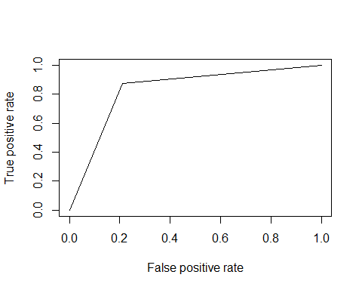

# 3.5 EXTREME GRADIENT BOOSTING

## 3.5.1 XGB model

library(xgboost)

library(plyr)

library(DMwR)  
  
fitControl <- trainControl(method="cv", number = 3,classProbs = TRUE )  
xgbGrid <- expand.grid(nrounds = 500,  
 max_depth = 20,  
 eta = .03,  
 gamma = 0.01,  
 colsample_bytree = .7,  
 min_child_weight = 1,  
 subsample = 0.9  
)  
  
  
HRAXGBmodel <- train(Attrition~., data = trainHRA,  
 method = "xgbTree"  
 ,trControl = fitControl  
 , verbose=0  
 , maximize=FALSE  
 ,tuneGrid = xgbGrid  
)

## 3.5.2 XGB model Prediction and Confusion Matrix

HRAXGBprd <- predict(HRAXGBmodel,testHRA)  
confusionMatrix(HRAXGBprd, testHRA$Attrition)

## Confusion Matrix and Statistics  
##   
## Reference  
## Prediction No Yes  
## No 85 19  
## Yes 10 123  
##   
## Accuracy : 0.8776   
## 95% CI : (0.829, 0.9165)  
## No Information Rate : 0.5992   
## P-Value [Acc > NIR] : <2e-16   
##   
## Kappa : 0.7492   
## Mcnemar's Test P-Value : 0.1374   
##   
## Sensitivity : 0.8947   
## Specificity : 0.8662   
## Pos Pred Value : 0.8173   
## Neg Pred Value : 0.9248   
## Prevalence : 0.4008   
## Detection Rate : 0.3586   
## Detection Prevalence : 0.4388   
## Balanced Accuracy : 0.8805   
##   
## 'Positive' Class : No   
##

## 3.5.3 XGB model AUC Curve

XGB.plot <- plot.roc (as.numeric(testHRA$Attrition), as.numeric(HRAXGBprd),lwd=2, type="b", print.auc=TRUE,col ="blue")

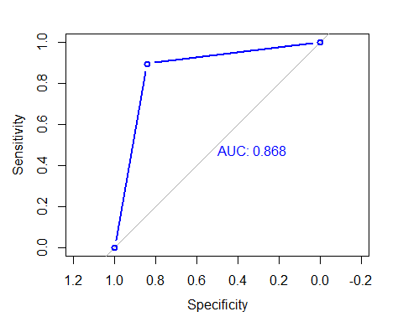

CHAPTER 5: KEY FINDINGS

Significant Variables identified in linear models are also used in Random forest

Below table provides a snapshot of the various models which the business can choose from based on the pros and cons of each model.

|  |  |  |  |  |
| --- | --- | --- | --- | --- |
| Sr. No | Model Name | Accuracy | Benefits | Trade-offs |
| 1 | Logistic_Regression_Model | 81.1 | High interpretability  Significant variables can be easily identified | May give lower accuracy |
| 2 | Decesion_Tree_Model | 79.4 | Significant variables are automatically selected. | May give lower accuracy without pruning. |
| 3 | Random_Forest_Model | 85.8 | Good Accuracy | Minimal / lower interpretability |
| 4 | SVM | 86.11 | boundary is established | Space and time taken is more |
| 5 | XGB | 86.8 | Highest Accuracy | Minimal / lower interpretability |

* We can examine the variable importance list, and see which factors in general are helpful in determining the outcome.

varImpPlot(randomforestHRA2)

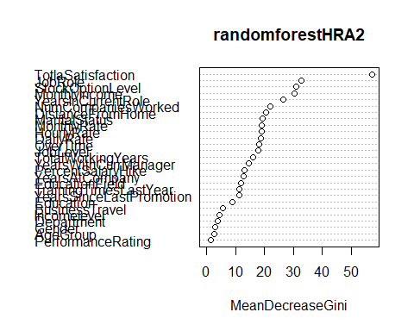

As we see here, Over time, Age, MonthlyIncome, Jobrole and TotalWorkingYears are top five variables.

Two of these are already familiar to us from our EDA and decision tree plot - it seems that we should indeed do something about those who work overtime and then leave and those who have a low monthly income (which is probably also linked to the job level).

CHAPTER 6: RECOMMENDATIONS AND CONCLUSION

* We have built a very simple models for predicting employee attrition, from some basic Exploratory Data Analysis to feature engineering as well as implementing learning models in the form of a Random Forest and a Gradient Boosting classifier and returns a 87% accuracy in its predictions.
* The main general reason behind attrition is most likely the ***effort-reward imbalance***. In this case, this mostly applies to people who are working overtime and who in many cases have a relatively low salary - it **should be checked whether there is an effective overtime policy in our company**
* Our simple decision tree shows that further solutions may not lie uniquely in people getting higher salaries (or their overtime pay). Those with relatively higher salaries may still leave if they do not feel part of the company (e.g. if they don't have any stock options, or if they don't have access to trainings);
* We have also found that different facets of **work-life balance** might represent an issue for our employees (a finding supported by visualizations and (at least to some extent) our best algorithm). the fact that all three variables linked (directly or indirectly) to work-life balance (distance from home, business travel, and work-life balance as such) have their place among the top 20 variables could also be a sign that something should be done in this area. Remember, we've already observed this pattern during the visualization phase.
* There seems to be a link between attrition and age as well as the number of companies worked for. At this point, we cannot provide more information and it would be necessary to delve deeper into our dataset, e.g. to ascertain whether this is not simply linked to retirements or to see whether there is an unfair treatment of certain age groups and whether specific part of our workforce is in need of an intervention (e.g. more job security, upskilling, etc.).
* If we take our "test" set as an example of IBM's current workforce, we can say that the **job role with highest probability of attrition is sales representative** - something should be definitely done about that, and we could explore further what exactly.
* We should also delve a bit more into the matter of age & number of companies the person worked for.

CHAPTER 7: REFERENCES

I am using a dataset put up by IBM for my analysis. The dataset contains 35 variables along with Attrition variable. It can be downloaded from:

<https://www.kaggle.com/pavansubhasht/ibm-hr-analytics-attrition-dataset>